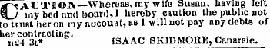
BROOKLYN EAGLE 11/26/1851

